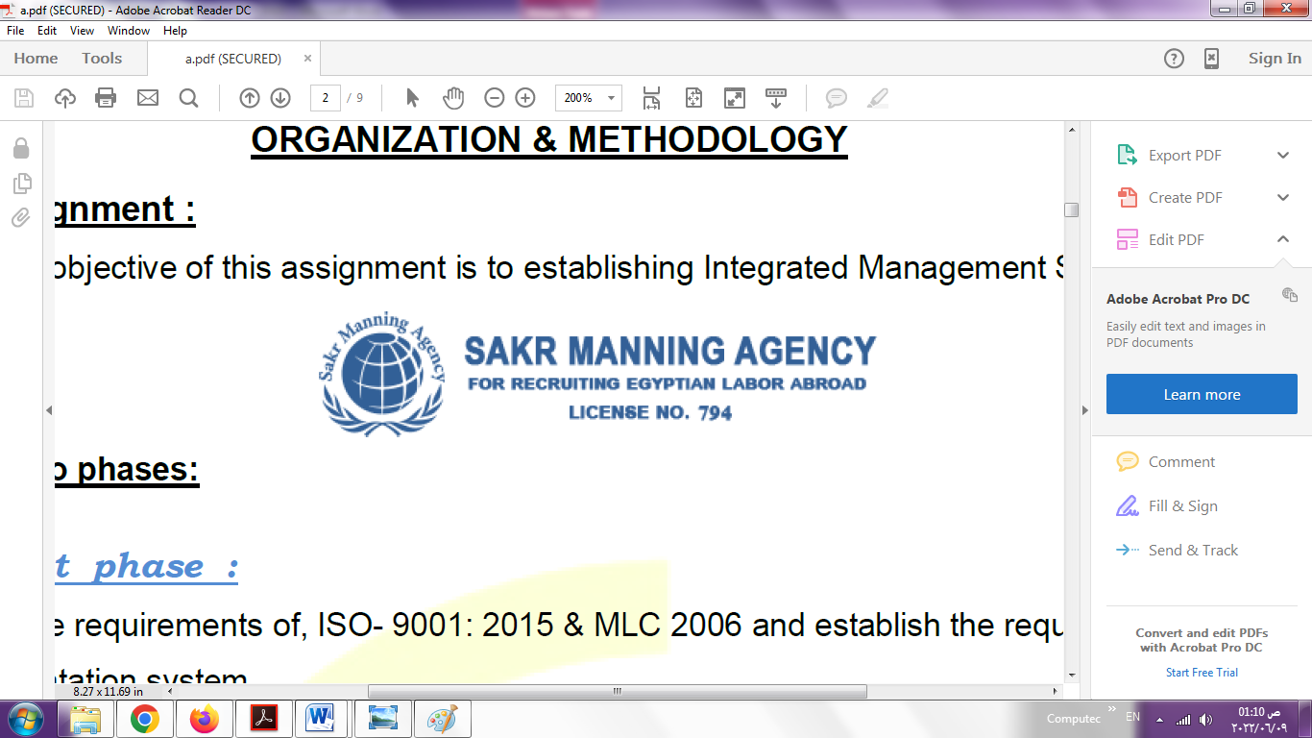 | SAKR MANNING AGENCY  FOR RECRUITING EGYPTIAN LABOR ABROAD | Issue Date | 15.05.2022
 |  | Revision Date | 19.07.2022
 | Crewing Management Manual  Seafarer Employment Application | Revision | 1.1
 |  | Page | 3
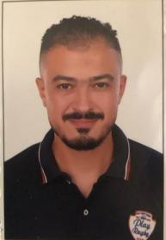
Application For Position as | OILER
Register Code. | ER-2.011
Other Position (If Any) | MECHANIC
Register Date | 25/7/2023
Last up Date Data | 19/5/2023

1. PERSONAL DETAILS
Full Name |  | MOHAMED IBRAHIM ABD ELAZIZ
Date Of Birth |  | 13/7/1989 |  |  |  |  |  |  | Place Of Birth |  |  |  |  |  |  |  | ALEXANDRIA
Nationality |  | EGYPT |  |  |  |  |  |  | Marital Status |  |  |  |  |  |  |  | Single /☐ |  |  |  |  |  |  |  | Married ☐
Height (Cm) |  | 175 |  |  |  |  |  |  | Overall Size |  |  |  |  |  |  |  | xl |  |  |  |  | Shirt Size |  |  |  |  |  | m
Weight (Kg) |  | 80 |  |  |  |  |  |  | Trouser Size |  |  |  |  |  |  |  |  |  |  |  |  | Shoes Size |  |  |  |  |  | 42
2. EDUCATION
College / School
Marline Test |  | Issued Date |  |  |  |  | Result % |  |  |  | Issued By (Authority) |  |  |  |  |  |  |  |  |  | Issued At
English Language |  | Fluent ☐ |  |  |  |  |  | Good /☐ |  |  |  |  | Average ☐ |  |  |  |  |  |  |  | Poor ☐
……… Language  ( ) |  | Fluent ☐ |  |  |  |  |  | Good ☐ |  |  |  |  | Average ☐ |  |  |  |  |  |  |  | Poor ☐
3. CONTACT DETAILS
Home Address / City |  |  | ALEXANDIRA /MAMI ABD ELNASSER DOARAN JAHAN
E-Mail |  |  | Mohamed arabey222@gmail.com |  |  |  |  |  |  | Mobile / Tel |  |  |  |  |  | 002-01095794585

4. TRAVEL DOCUMENTS
Type |  | Document No. |  |  |  | ISS. Date |  |  | Exp. Date |  |  |  |  | ISS. By (Authority) |  |  |  |  |  |  |  |  |  | Place of Issue
Passport |  | A20459549 |  |  |  | 18/4/2017 |  |  | 17/4/2024 |  |  |  |  | Egyptian Authority
Seaman Book |  | S00006355 |  |  |  | 20/2/2020 |  |  | 14/1/2025 |  |  |  |  | EAMS |  |  |  |  |  |  |  |  |  | Alex.
Other Seaman Book

5. PROFESSIONAL QUALIFICATION / CERTIFICATE OF COMPETENCY
Certificate Name |  |  |  |  | Number | Issue Date |  |  |  |  |  | Expiry Date |  |  |  |  |  | Issued By |  |  |  |  |  |  |  |  | Issued At
COC |  |  |  |  |  |  |  |  |  |  |  |  |  |  |  |  |  | EAMS |  |  |  |  |  |  |  |  | Alex.
GOC |  |  |  |  |  |  |  |  |  |  |  |  |  |  |  |  |  | NTRA |  |  |  |  |  |  |  |  | Cairo
D.P. INDUCTION
D.P. ADVANCED
D.P. OPERATOR (UNLIMITED)
6. NEXT OF KIN
Full Name |  |  |  |  |  |  |  |  |  |  |  |  |  |  | Relationship
Address
Tel. No. |  |  |  |  |  |  |  |  |  | Mobile
7. HEALTH CERTIFICATES & VACCINATIONS
Flag State |  |  |  | Number |  |  | Issue Date |  |  |  |  | Expiry Date |  |  |  |  |  |  | Issued By |  |  |  |  |  |  | Issued At
International Medical |  |  |  | 15254 |  |  | 11/6/2023 |  |  |  |  | 14/1/2025 |  |  |  |  |  |  | EAMS |  |  |  |  |  |  | Alex.
Yellow Fever |  |  |  |  |  |  |  |  |  |  |  |  |  |  |  |  |  |  | Ministry of Health
Cholera |  |  |  |  |  |  |  |  |  |  |  |  |  |  |  |  |  |  | Ministry of Health
Covid-19 |  |  |  | Vaccination Name |  |  | First Dose |  |  |  |  | Second Dose |  |  |  |  |  |  | (Other Does or Remarks)
 |  |  |  | JOHNSON |  |  | 9/9/2021 |  |  |  |  | 17/10/2022

8. MARINE COURSES
Course Name | Number | Issue Date | Expiry Date | Issued By / At
Personal Survival Techniques | 18185 |  | 19/1/2025
Proficiency In Personal Survival Techniques
Fire Prevention and Fire Fighting
Advanced Fire Prevention and Fire Fighting | 18184 |  | 17/1/2025
Elementary First Aid | 18183 |  | 14/1/2025
Medical Care Studies | 02626 |  | 14/9/2024
Personal Safety and Social Responsibilities | 100000595 |  | 31/12/2023
Proficiency Of Security Awareness Training Seafarers
Proficiency as a ship Security officer ( PSSO )
Proficiency In Survival Craft & Rescue Boats
G.M.D.S.S
Communications
Advanced Communications
ECDIS Advanced Simulator (Management Level)
ECDIS Simulator (Operation Level)
Prevention and Combating of Marine Pollution
Radar & ARPA Simulator and Search &rescue
ARPA Simulator and Search
Marine Radar and automatic Radar Plotting
Bridge resource Management (B.R.M)
Engine resource Management (E.R.M)
Navigational Watch keeping
Proficiency for Rating forming part of Navigational watch (II/4) |  |  |  | EAMS / Alex.
High voltage training – operation of ship (1000 Volt and More)
Passenger Safety Cargo Safety and Hull integrity
Crowd Management Training
Crisis Management and Human Behavior Training
Safety training for Personal Prov. Direct Passengers
Practical Ability to Prepare Meals and (MLC 2006)
Personal Hygiene and Envir. Protection (MLC 2006)
Safety and Health in the Provision Meals (MLC 2006)
Food Storage and inventory Control (MLC 2006)
Ships Cook Certificate (MLC 2006) |  |  |  | EAMS / Alex.
Abel Seafarer Deck
Proficiency for Abel Seafarer Deck ( II/5 ) |  |  |  | EAMS / Alex.
Engineering Watch keeping |  |  |  | EAMS / Alex.
Proficiency for Rating forming part of a watch in engine room
Abel Seafarer Engine
Proficiency for Abel Seafarer Engine ( III/5 ) | 200068180 |  | xxxxxxxx | EAMS / Alex.
Electro Technical Rating
Proficiency for Electro Technical rating ( III/7 ) |  |  |  | EAMS / Alex.

COMPLETE SEA – SERVICE DETAILS

Name: |  |  |  |  |  |  |  | Rank: |  |  |  |  |  |  |  | Register Code:
Company Name |  |  | Rank |  | Vessel Name |  |  |  | Signed On |  |  | Signed Off |  |  |  | Period |  |  | Vessel Type |  | D.W.T. |  |  |  |  | Engine Type |  |  | BH | KW
ZAKHER MARINE |  |  | MECHANIC |  | ZAKHER EMPEROR |  |  |  | 19/3/2011 |  |  | 15/8/2011 |  |  |  |  |  |  | ahts |  | 3840 |  |  |  |  | caterpiler |  |  | 3516
MERJO MARINE |  |  | MECHANIC |  | SEA PRINCE |  |  |  | 30/10/2011 |  |  | 26/11/2012 |  |  |  |  |  |  | Crew boat |  | 2x1400 |  |  |  |  | caterpiller |  |  | 2300
NAMMA SHIPPING |  |  | MECHANIC |  | MAHABBAH |  |  |  | 02.12/2012 |  |  | 1/7/2013 |  |  |  |  |  |  | Roro pax |  | 1850 |  |  |  |  | piestick |  |  | 2x9450
NAMMA SHIPPING |  |  | MECHANIC |  | MAHABBAH |  |  |  | 1/8/2013 |  |  | 1/2/2014 |  |  |  |  |  |  | roro |  | 1850 |  |  |  |  | pielstick |  |  | 2x9450
NAMMADHIPPING |  |  | MECHANIC |  | MAHABBH |  |  |  | 1/4/2014 |  |  | 30/10/2014 |  |  |  |  |  |  | roro |  | 1850 |  |  |  |  | piestick |  |  | 2x9450
NAMMA SHIPPING |  |  | MECHANIC |  | MAWADDAH |  |  |  | 1/12/2014 |  |  | 1/5/2015 |  |  |  |  |  |  | roro |  | 3097 |  |  |  |  | mak |  |  | 2x3000
NAMMA SHIPPING |  |  | MECHANIC |  | NAMME EXPPERESS |  |  |  | 25/5/2015 |  |  | 1/11/2015 |  |  |  |  |  |  | roro |  | 4734 |  |  |  |  | piestick |  |  | 9m453
NAMMA SHIPPING |  |  | MECHANIC |  | MAHABBAH |  |  |  | 1/1/2016 |  |  | 15/10/2016 |  |  |  |  |  |  | Roro pax |  | 1850 |  |  |  |  | gutes |  |  | 2x9450
MERJO MARINE |  |  | MECHANIC |  | GUPCO1 |  |  |  | 17/7/2017 |  |  | 15/4/2017 |  |  |  |  |  |  | tug |  | 850 |  |  |  |  | cummins |  |  | 1600x2
ALPHARD MARTIME |  |  | MECHANIC |  | AM AFFINTY |  |  |  | 24/2/2018 |  |  | 19/1/2018 |  |  |  |  |  |  | tug |  | 1193 |  |  |  |  | sulzer |  |  | 2x1000
FADAK MARINE |  |  | MACHANIC |  | SAIF 1 |  |  |  | 15/8/2018 |  |  | 15/7/2018 |  |  |  |  |  |  | container |  | 1429 |  |  |  |  | diahatsu |  |  | 10rnd90
MERJO MARINE |  |  | MECHANIC |  | SEA WAVE |  |  |  | 115/8/2018 |  |  | 21/6/2019 |  |  |  |  |  |  | Ants dp2 |  | 1570 |  |  |  |  | diahatsu |  |  | 3060
UPPER MARINE |  |  | MECHANIC |  | SEA STAR |  |  |  | 10/3/2020 |  |  | 12/8/2020 |  |  |  |  |  |  | ants |  | 850 |  |  |  |  | afico |  |  | 2x1000
OVER SEA MARINE |  |  | MECHANIC |  | MKN203 |  |  |  | 4/11/2020 |  |  | 7/6/2021 |  |  |  |  |  |  | Ants dp2 |  | 3x350 |  |  |  |  | nllgata |  |  | 2x3500
GSP OFF SHORE |  |  | MECHANIC |  | GSP LICRRN |  |  |  | 8/11/2022 |  |  | 1/3/2023 |  |  |  |  |  |  | PSV |  | 5460 |  |  |  |  | CATERPILLE |  |  | 4010
SPECIALISED EXPERIENCE
Name |  |  |  |  |  |  |  |  |  | Type |  |  |  | From |  |  | To |  |  |  |  | Comments
MOHAMED EBRAHIM ABD ELAZIZ AMEEN |  |  |  |  |  |  |  |  |  | No
I declare that the information I have given is, to the best of my knowledge, true and complete. I also declare that the documents submitted are genuine, given and sign by persons whose names appear on them.
 |  |  |  |  |  |  |  |  |  |  |  |  | 21/7/2023 |  |  |  |  |  |  |  |  |  | MOHAMED
 |  |  |  |  |  |  |  |  |  |  |  |  |  |  | DATE |  |  |  |  |  |  |  |  |  | SIGNATURE

